Level 0, level 1 and level 2 Data Flow Diagrams (DFD) for a web application for career information and recruitment. The applications connect colleges, students, alumni students and recruiters on a common platform.

**Career Information and Recruitment Portal**

Data Flow Diagrams

Group Members:

Jincy P Janardhanan (IEAREIT017)

Alka Bhagavaldas (IEAREIT007)

Ameena Shirin (IEAREIT009)

Aleena Sunny (IEAREIT006)



# Level 0

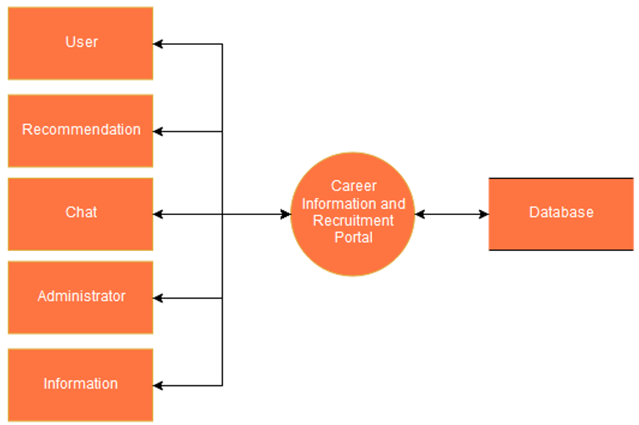

Figure 1. Level 0 - Context diagram for Career information and recruitment portal

# Level 1 Diagrams

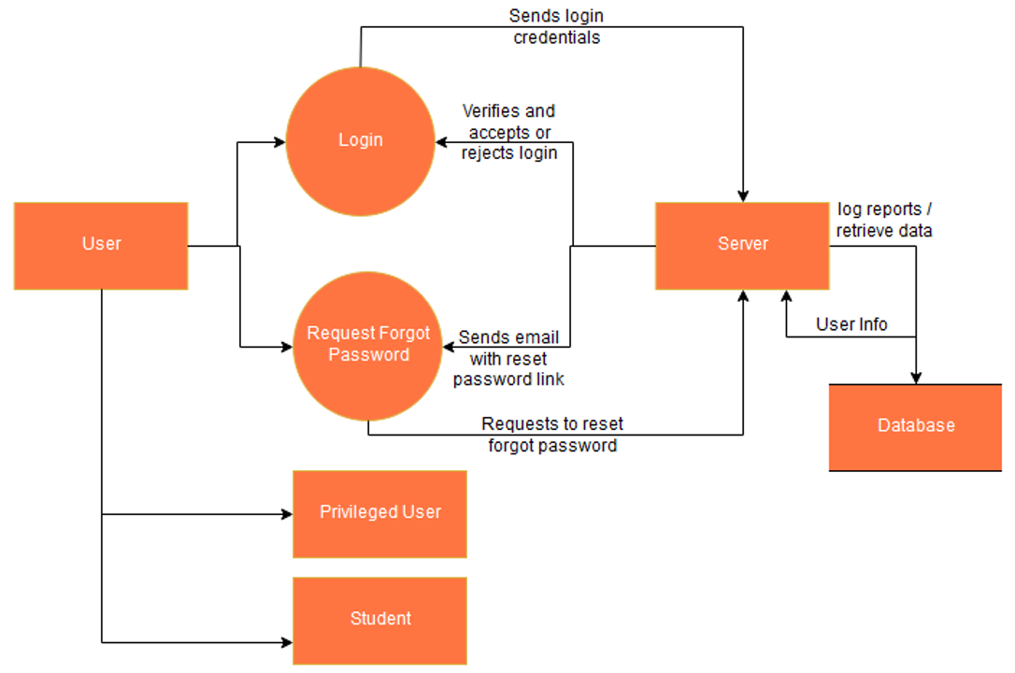

Figure 2. Level 1.1 - User module (implemented as class)

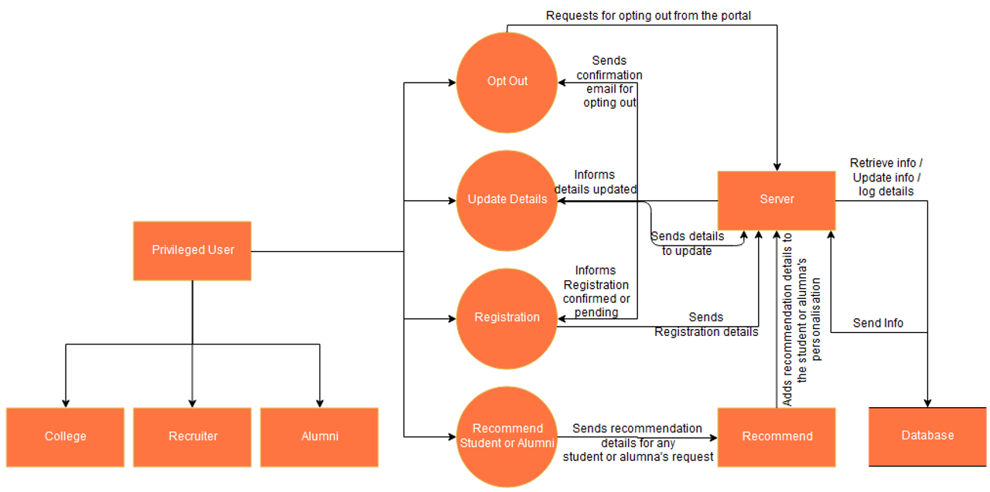

Figure 3. Level 1.1.1 - Privileged User (sub-module of User (1.1), implemented via interfaces only)

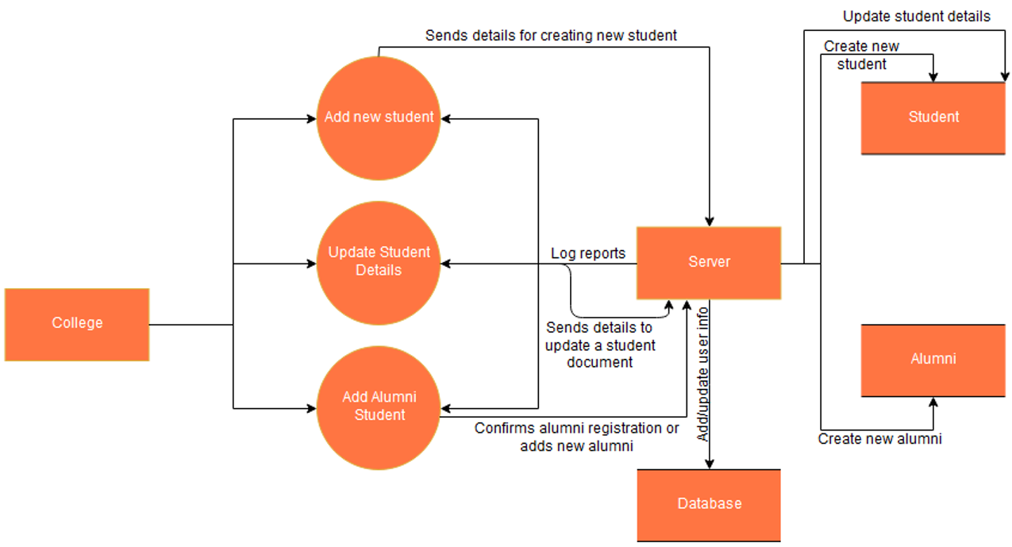

Figure 4. Level 1.1.1.1 - College module (implements Privileged User interface, implemented as class)

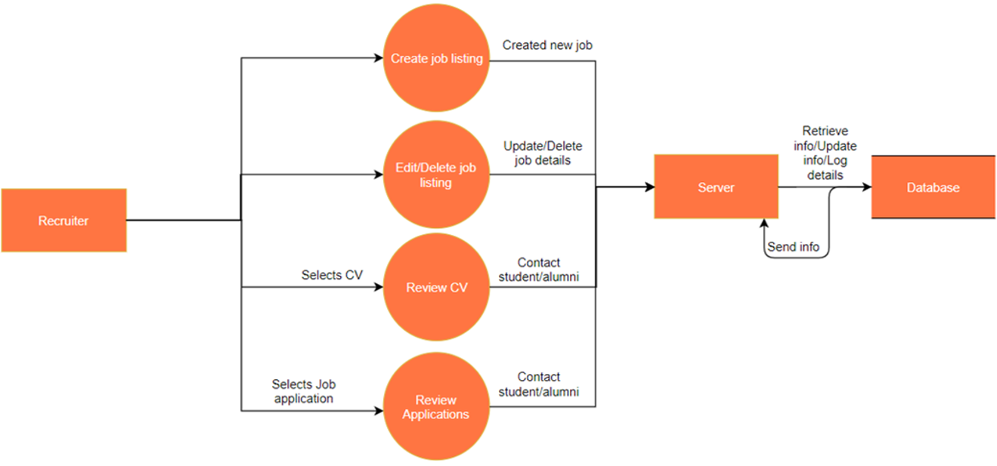

Figure 5. Level 1.1.1.2 - Recruiter module (implements Privileged User interface, implemented as class)

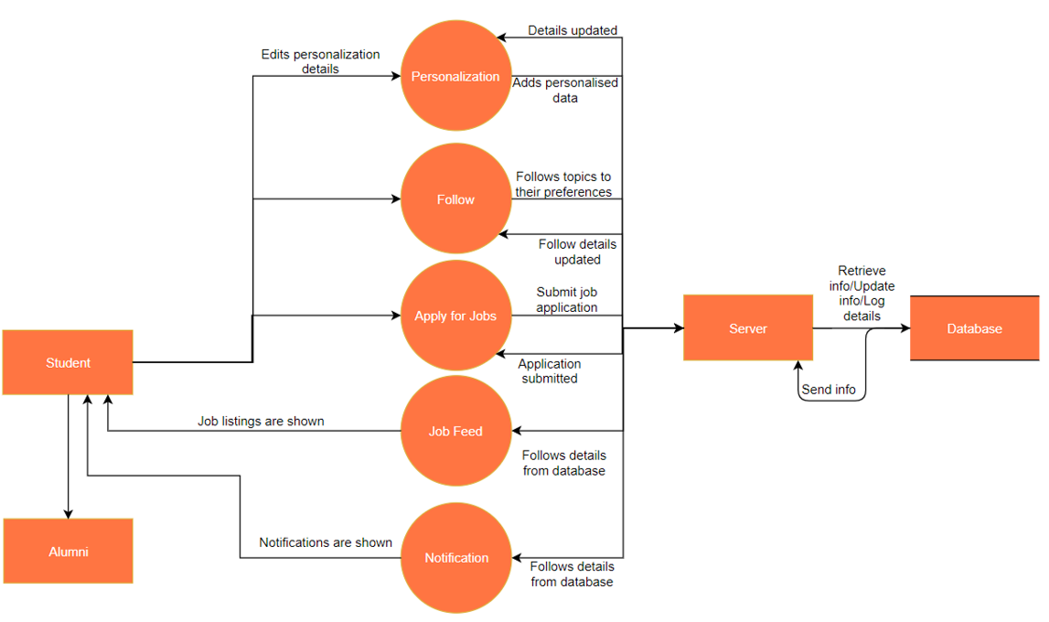

Figure 6. Level 1.1.2 - Student (Sub-module of User (1.1), implemented as class)

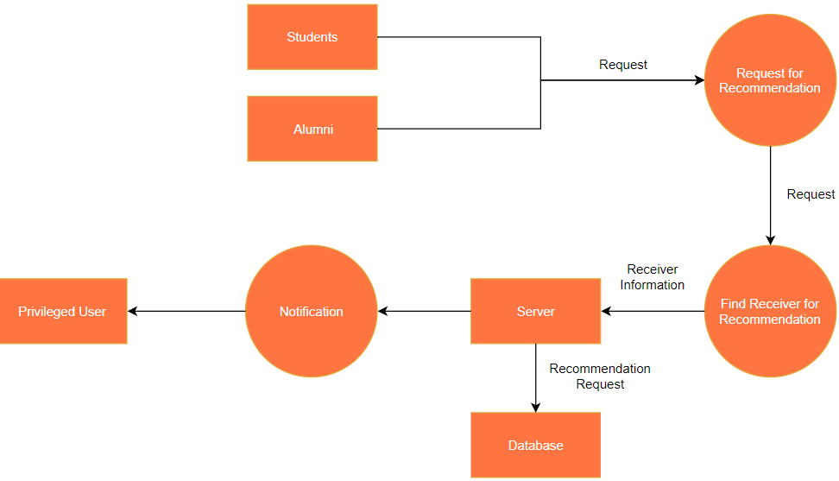

Figure 7. Level 1.2.1 - Request Recommendation (Recommendation module (1.2) has 2 functions - Request Recommendation and Recommend, both are implemented via separate interfaces and hence considered as sub-modules.)

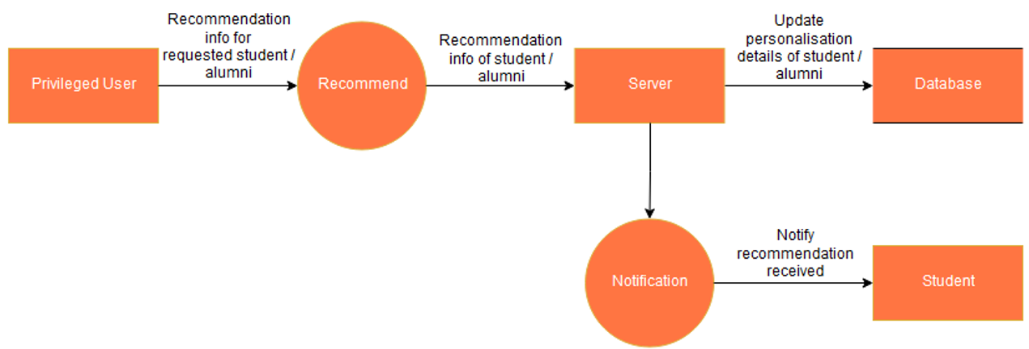

Figure 8. Level 1.2.2 - Recommend (Recommendation module (1.2) has 2 functions - Request Recommendation and Recommend, both are implemented via separate interfaces and hence considered as sub-modules.)

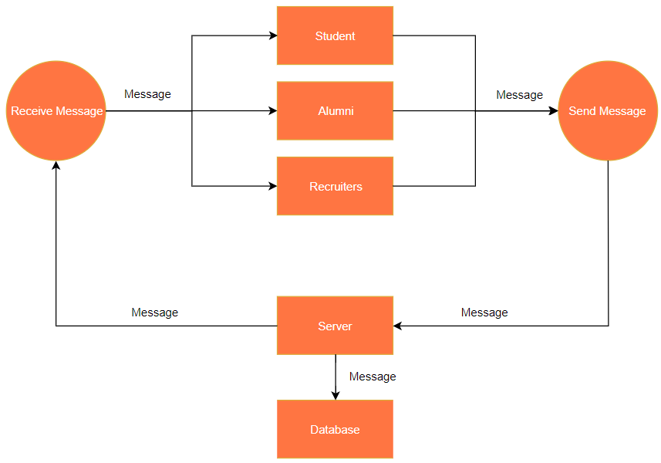

Figure 9. Level 1.3 - Chat (Implemented via interfaces only, implemented by Recruiter and Student classes)

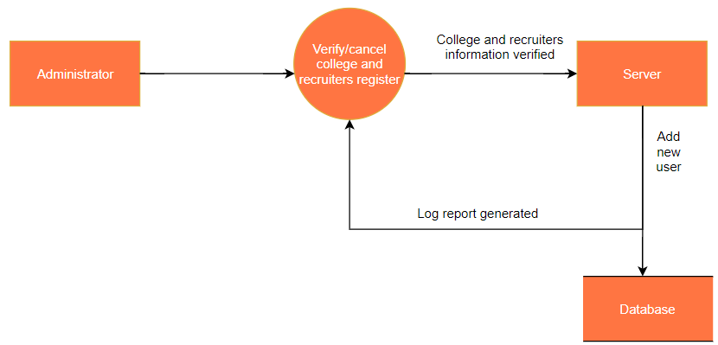

Figure 10. Level 1.4 - Administrator module (Implemented as class)

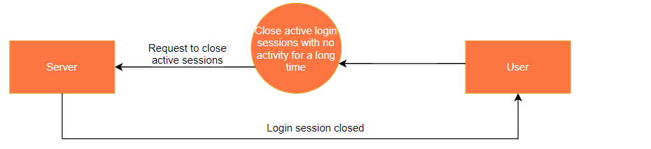

Figure 11. Level 1.5 - Server module (Implemented as class)

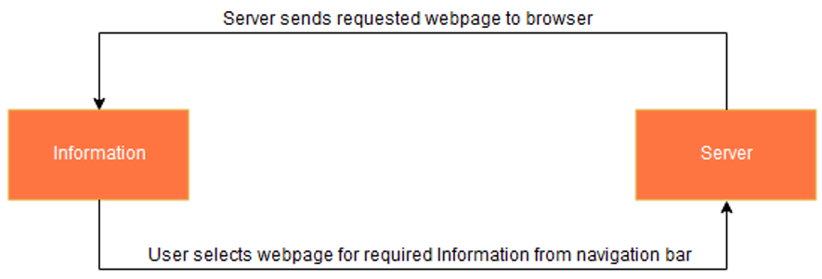

Figure 12. Level 1.6 - Information module (module used to display web pages for career information)

# Level 2 Diagrams

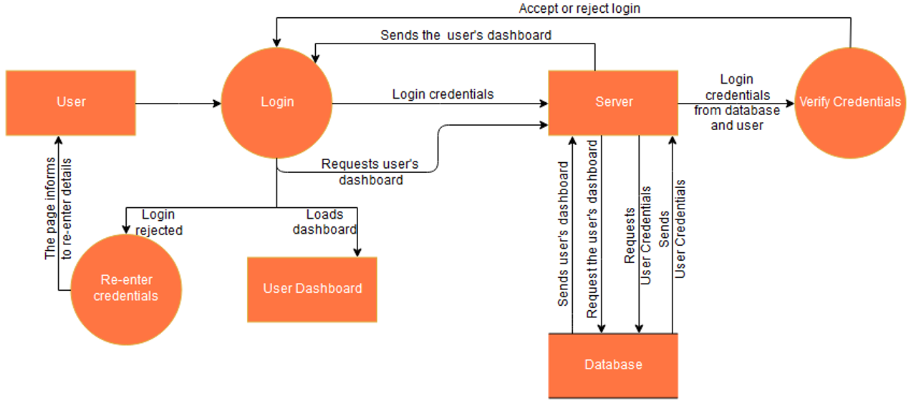

Figure 13. Level 2.1 - User login

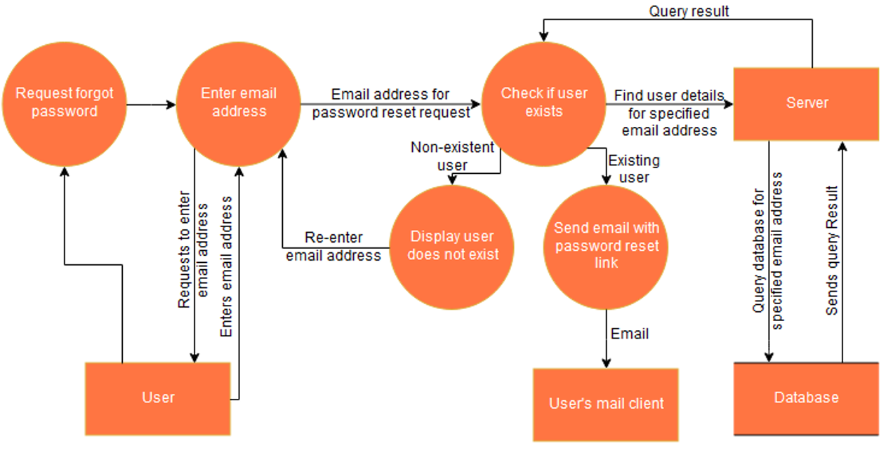

Figure 14. Level 2.2 - Request for forgot password

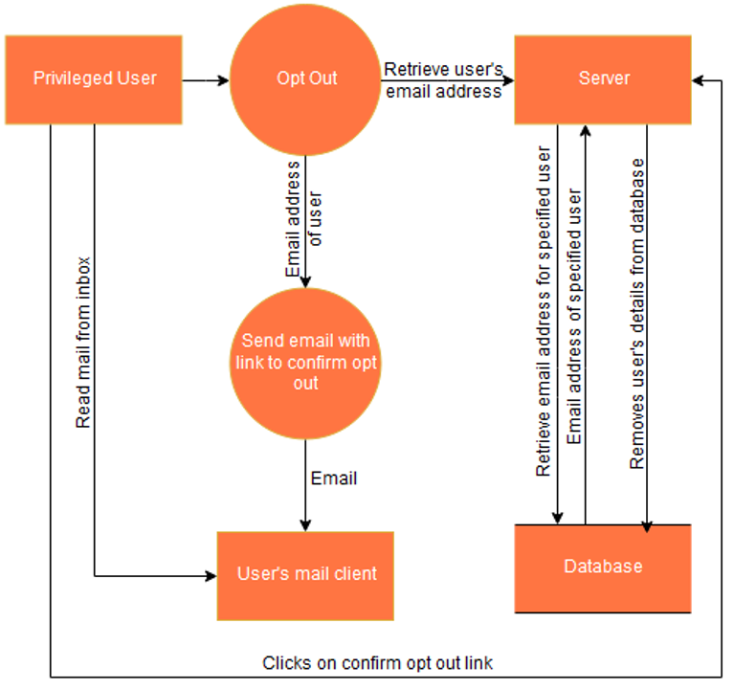

Figure 15. Level 2.3 - Opt out request by any privileged user

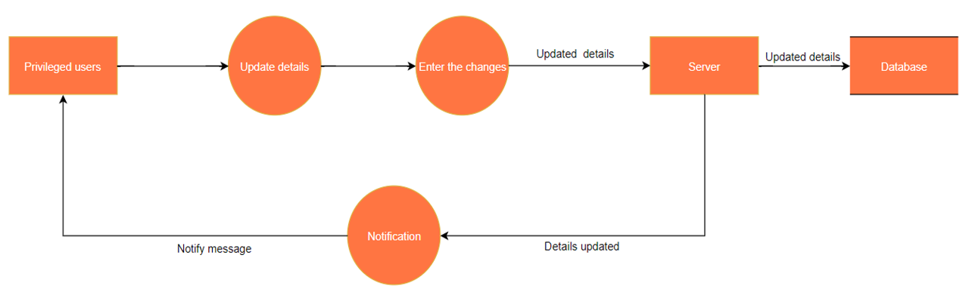

Figure 16. Level 2.4 - Update details of any privileged user

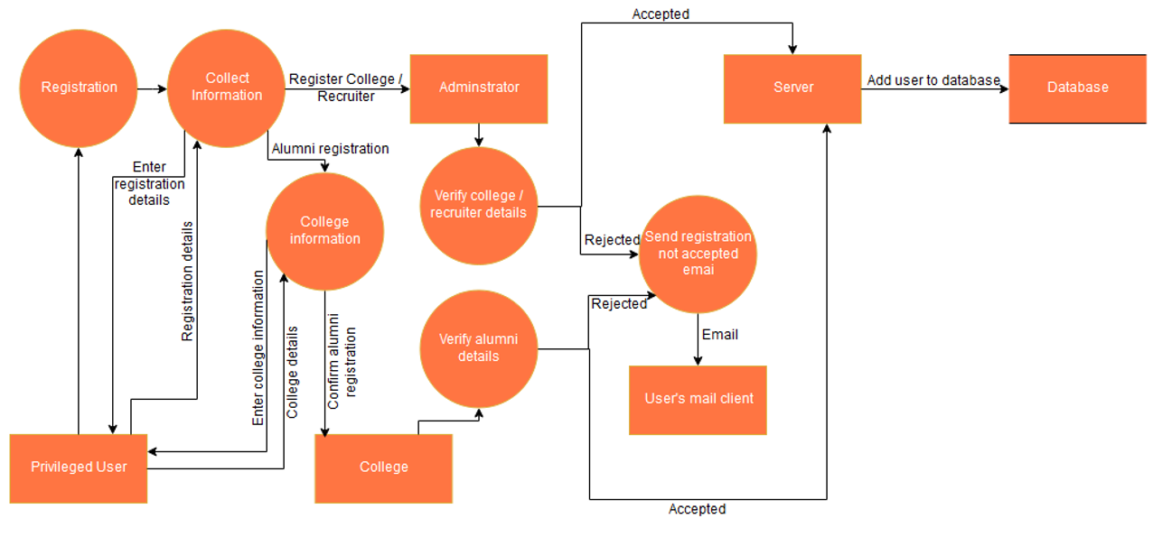

Figure 17. Level 2.5 - Registration of any privileged user

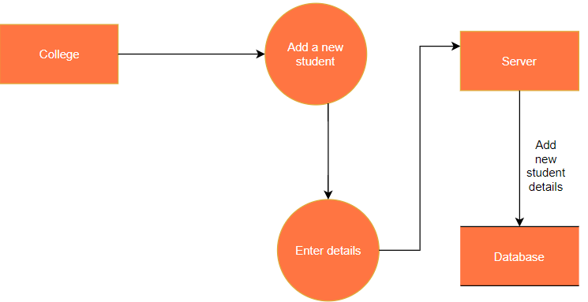

Figure 18. Level 2.6 - Add new student by college

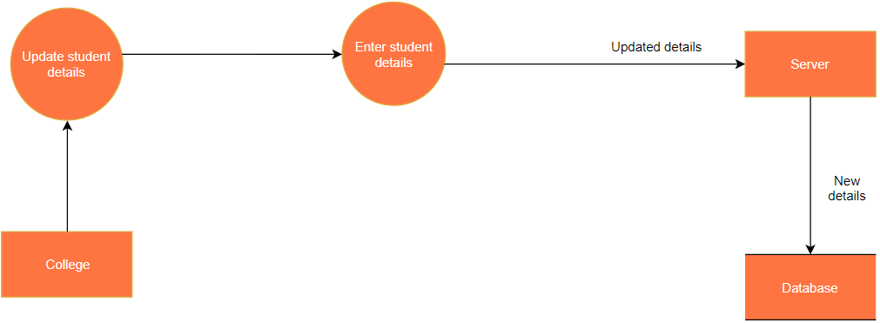

Figure 19. Level 2.7 - Update student details by college

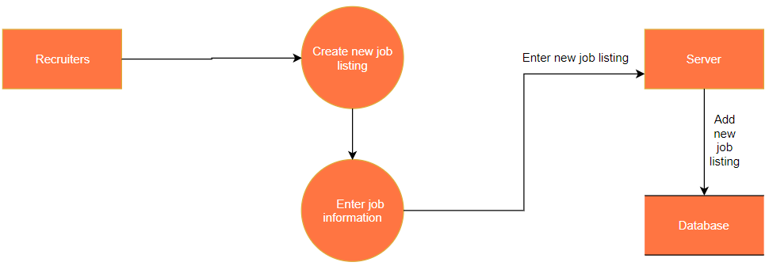

Figure 20. Level 2.8 - Create new job listing by Recruiter

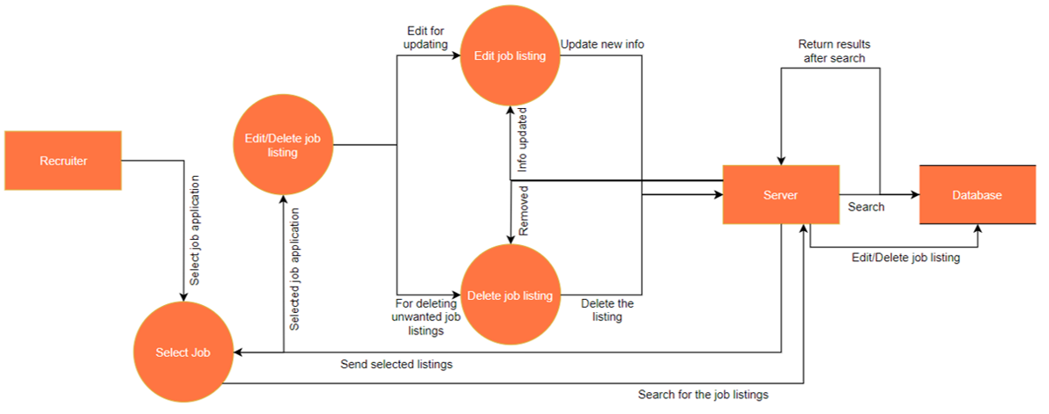

Figure 21 Level 2.9 - Edit or delete job listing by recruiter

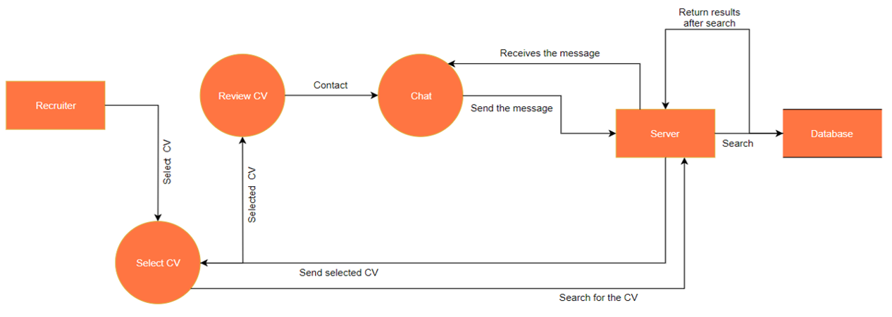

Figure 22. Level 2.10 - Review CV by Recruiter

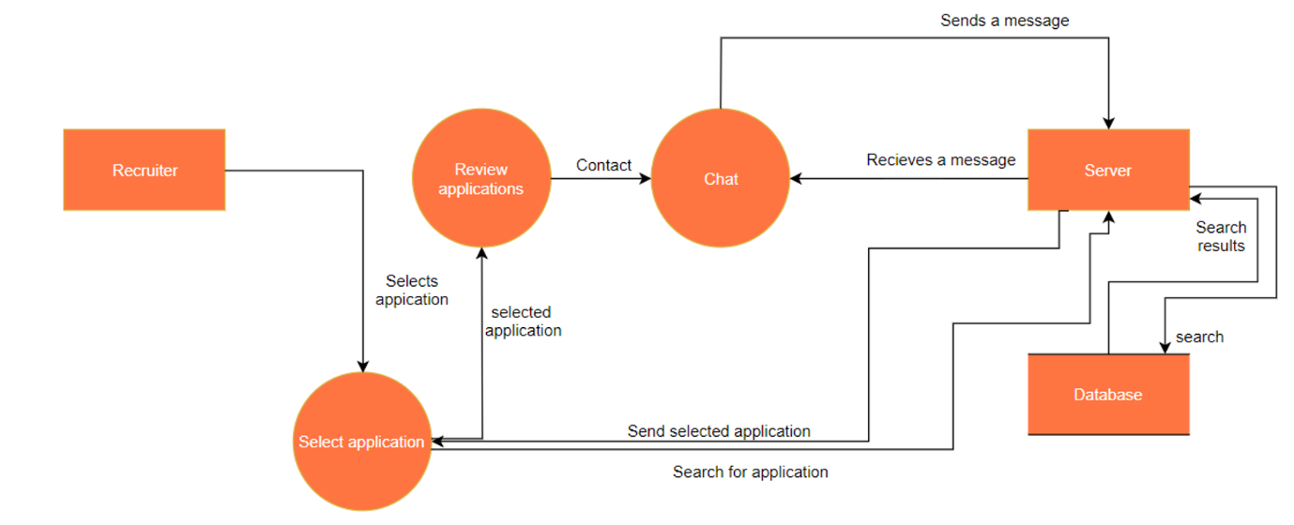

Figure 23 Level 2.11 - Review applications by recruiter

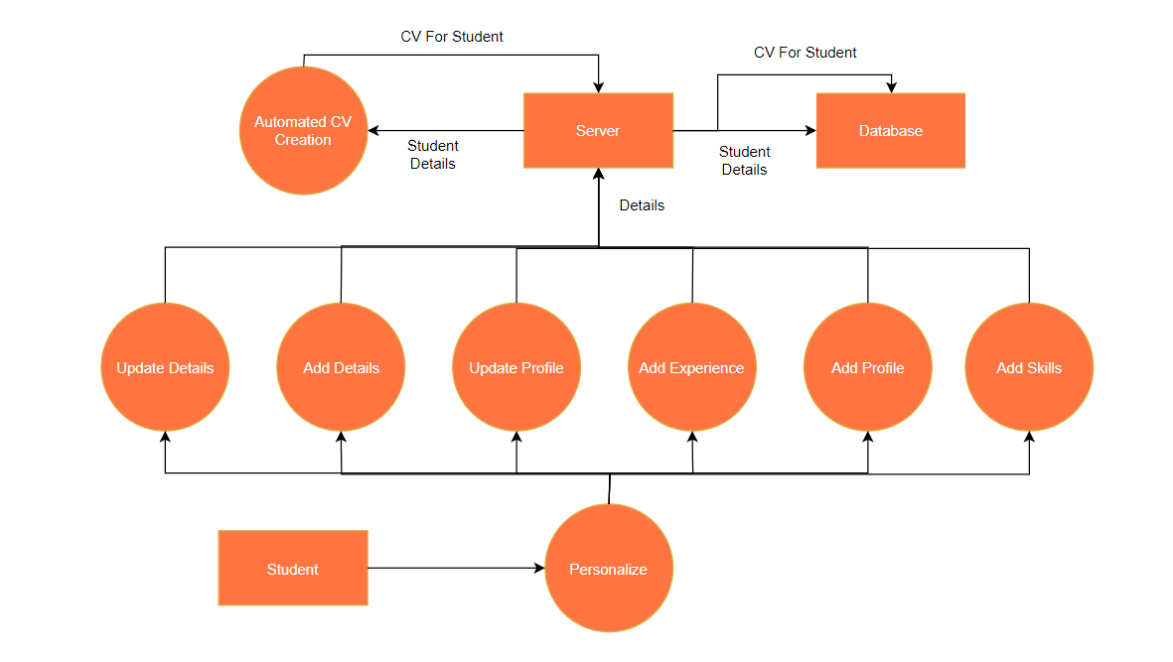

Figure 24. Level 2.12 - Entering personalization details by student

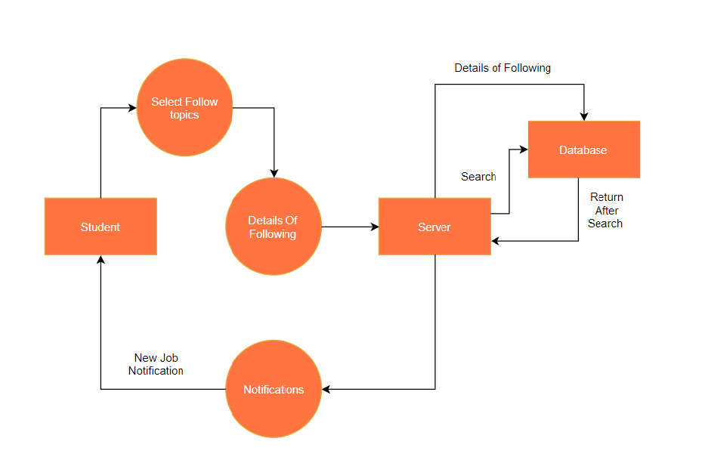

Figure 25. Level 2.13 - Following topics or recruiters by student

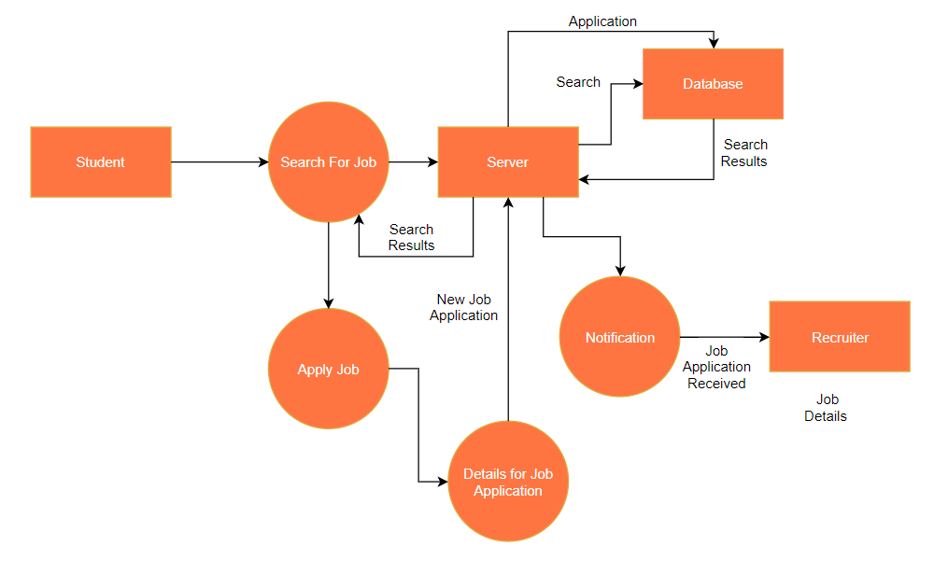

Figure 26. Level 2.14 - Apply for job by student